EMERGENCY BREAK ASSISTANCE AND SENSORS

Developed by
JYOTHIKA UDUGULA
03/07/2021

ABSTRACT:
Vehicle technology has increased rapidly in recent years, particularly in relation to braking systems and sensing systems. ASS (active safety systems) are being researched and developed to prevent accidents and target mitigation. Among many useful active safety systems, it has been reported that AEBS (Advanced Emergency Braking Systems) effectively prevents accidents and reduces casualties simultaneously. The project aims to distinguish between systems currently in production like traction control (TC), electronic brake force distribution (EBD), brake assist (BA) and electronic stability control (ESC) functions and future systems that are currently in development. The project aims to develop a prototype system that offers a collision functionality in production vehicle, a system which can operate automatically with the help of high profile sensors based relay circuit and some modification in traditional braking system that can alert the driver in front collision and apply the brake automatically in emergency or critical
Keywords: ASS (active safety systems),AEBS (Advanced Emergency Braking Systems), brake assist (BA), electronic stability control (ESC)

1. INTRODUCTION

Driving is a compulsory activity for most people. People use their car to move from one place to other place. The number of vehicles is increasing day by day.
Nowadays, accidents are increasing and are uncertain. Accident will occur every time and everywhere and cause worst damage, serious injury and even death. These accidents are mostly caused by delay of the driver to hit the brake.
This project is designed to develop a new system that can solve this problem where drivers may not brake manually but the vehicles can stop automatically by detecting obstacles.
This project is about a system that can control Braking system for safety. Using ultrasonic as a ranging sensor, its function based on ultrasonic wave.
After transmitting by transmitter, the wave can reflect when obstacle is detected and then received by receiver. The braking circuit’s function is to slow down or stop the car automatically after receiving signal from the sensor.
The objectives of this project are i. To develop a safety car braking system using ultrasonic photoelectric retro reflective sensors. ii. To design a vehicle with less human attention to the drivingScope of project is to develop an ultrasonic sensor to detect the obstacle and to process the output from the ultrasonic sensor and to drive the pneumatic cylinderbraking system for safety.

Using ultrasonic as a ranging sensor, its function based on ultrasonic wave. After

transmitting by transmitter, the wave can reflect when obstacle is detected and then received by receiver.
The braking circuit’s function is to slow down or stop the car automatically after receiving

signal from the sensor. The objectives of this project are
i. To develop a safety car braking system using ultrasonic photoelectric retro reflective sensors.
ii. To design a vehicle with less human attention to the drivingScope of project is to develop an ultrasonic sensor to detect the obstacle and to process the output from the ultrasonic sensor and to drive the pneumatic cylinder

2. LITERATURERE REVIEW

2.1 Safety Consideration in Cars
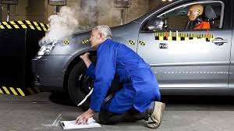
There are various safety consideration involve
to make passenger comfortable while traveling,and it has been modified as generation of automobile goes by.
Here are some area the modification has been take place:
2.1.1 Strong Chassis
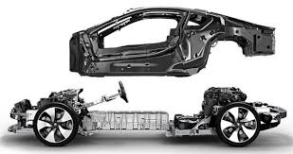
In old days the chassis were made of wooden floor and not good enough to sustain the load. But now days the chassis is made of alloy of lightweight aluminum and strong cast iron to give chassis immense strength such that it withstand load and sustain make it in accident.

2.1.2 Dash Board Modification
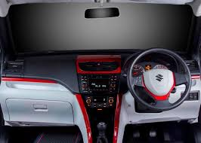
The Dash board is modified and simplified in recent days such that it can be user friendly. Ergonomics (the relation between man & machine) of dash board include various sensors and meters to
2.1.3 Implementation of Air Bags
Airbags (passive restraints) have saved many lives and reduced injuries in vehicle crashes, there are accidents where they have been the cause of injury and/or death. Knowledge of the history of airbag systems and how they work is important in understanding if they are a factor in an occupant’s injury or death. An overview of these subjects

2.1.4 Power Braking, ABS, Power starring, TRC
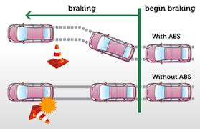
Today many path braking technologies and brake components such as brake boosters, brake cylinders, brake hydraulic valve, brake lines, etc., lend a braking system high efficacy. They are also the key behind advanced braking systems such as the anti-lock braking system. The following are some braking systems and their components.
2.2 Types of Brakes
2.2.1 Disc Brakes Disc
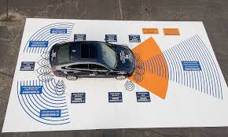
brakes make use of friction generated between the disc attached to a heel and the wheel itself, to slow or stop an automobile. Disc brakes comprise brake pads that serve as friction material and are fixed onto a device called a brake caliper. When the brake pedal is pushed by a driver the brake pads are mechanically, hydraulically, pneumatically or electromagnetically forced against both sides of the disc mounted on wheels thus regulating the speed of the vehicle or slowing down the vehicle.
2.2.2DrumBrakes Louis
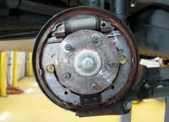
Renault is credited for inventing the modern drum brakes in 1902 to regulate speed by causing friction between the wheels and a set of shoes or pads that push against the inside surface of a rotating drum. The drum is attached to the rotating wheels. Typically, drum brakes are classified as either leading/trailing or twin leading. Out of the two types, the twin leading drum brakes are more effective.

2.2.3 Hand Brakes
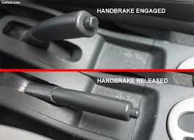
Hand brakes are latching brakes and are normally used to keep an automobile stationary, when not being driven. Also known as e-brake, emergency brake, park brake, parking brake or slide stick, the brakes are often configured on the floor and between front passenger and the driver. However, they can even be configured as a lever at the bottom of the dashboard, or as a footoperated pedal. The brake comprises a cable that connects the braking system at one end and a lever on the other. The driver operates the hand-lever (or a pedal) to actuate or release the brake.
2.2.4 Power Brakes
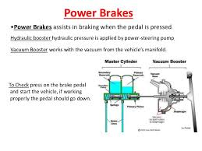

employing power braking uses the engine's power and/or the power of batteries to assist the driver in braking. Although conventional brakes generate enough force to regulate the speed of an automobile, power brakes further enhance this power by supplementing it from other sources (i.e. engine/batteries), thus causing highly efficient braking. Ex
2.2.5HydraulicBrakes Hydraulic brakes 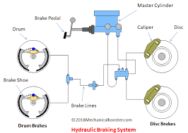

consists of a braking mechanism that uses brake fluid, to apply the braking force from the controlling unit (viz. brake pedal) to the actual brake mechanism. They are based on a multiple piston system, wherein the brake pedal when pushed, produces an equivalent force on each of the output pistons, thus multiplying the force and cause efficient braking.
2.3 Rear End Collisions
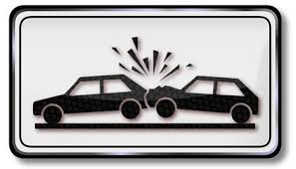
Three databases from three different countries are used as the basis for the problem definition to find types of collisions. Volvo's statistical accident database contains Volvo vehicles in Sweden in which the repair cost due to an accident exceeds a specified level, currently SEK 45000. The database, which contains information about the crash, the vehicles and the occupants including injuries if any, is further described. The GIDAS database (German In-Depth Accident Study) is the second European database used in this study
Traffic accidents within Hanover and Dresden and the rural areas surrounding these cities are investigated according to a statistical sampling process. As a complement to the European data, NASS/CDS (National Automotive Sampling System Crashworthiness Data System) is also used. CDS provides in-depth crash investigations of a representative sa mple of police-reported tow-away
crashes throughout the United States. Data is weighted to provide a nationwide estimate of all types of crashes and injuries. Focusing on light vehicle crashes in the NASS/GES database, show that rear-end collisions are most frequent among all crash types accounting for 29% of all crashes. Approximately 50% of all impacts are to the front of the vehicle. Frontal impacts into an opponent motor vehicle's rear end account for 6-9% of the total share. In Germany approximately 12% of all accidents with persons injured and approximately 20% of all material damage accidents are caused by cars in rear end collisions. As a consequence, Bosch is introducing collision avoidance and mitigation systems for rear impact scenarios. Warning, brake support, and autonomous emergency braking are part of Bosch's Advanced Emergency Braking Systems which address such accidents. This study determines the benefit of these assistance and safety systems and estimates the collision avoidance capability considering the driver’s behavior. By analyzing representative accidents with injuries from the GIDAS (German In-Depth Accident Study) database, a high potential for collision warning and avoidance systems was determined. For the first time in such a study, this analysis considers the effects of different driver reactions due to warning, braking support, or autonomous braking with respect to the
• 1st scenario:
Subject vehicle approaches a stopped principle other vehicle at 45mph (72.5kph). The system must give a warning 2.7s prior to collision.
• 2nd scenario:
Subject vehicle follows principle other vehicle at 45mph (72.5kph). The other vehicle starts braking. The system must give a warning 2.4s prior to collision. • 3rd scenario: Subject vehicle at 45mph (72.5kph) encounters a slower principle other vehicle with speed
20mph (32.2kph). The system must give a warning

3. WORKING PRINCIPLE

The system is consist of two photoelectric distance measurement sensors, kit of electronic control unit to give input and output of sensor, hydraulic circuit and single acting hydraulic cylinder . The sensor is having 15volt supply and can measure hurdle upto 10m .The Brake Kit is going to be fabricate having redesign brake paddle with reduced mass. The hydraulic cylinder we are using is single acting spring return type having solenoid valve.
Procedure :
Let us Consider that A Vehicle Speeding at 25Km/h Constantly and think worst case that Driver is Fallen asleep While Driving And Vehicle is Approaching to a park car at same speed, so here is how the Auto brake System will Work
1. The Photo electric Sensor Which will sense the any object in Front and Will give Continues output while on go ,in this case if car in front comes in contact with the sensor it will give output to the Electronic Control Unit
2. Thus ECU automatically alert the driver by blowing the alarm, thus if Driver here the alarm, the Distraction phase of Driver such that (Sleeping while Driving, Use of Mobile, Gossiping or doing any other Activity)will come

to end and he will take control of the situation and further damage can be Prevented.
3. If Driver does not Respond to this Alarm mean that no action is implies to stop the

vehicle then ECU will send the signal to hydraulic circuit.
4. Thus Stroke Of Hydraulic cylinder will start and lead to Auto Forcing the Brake Paddle to engage Position and lead to stopping the Vehicle, if in case Driver reaction lead to take control the situation , Driver will apply the force on Paddle then the Connection Between the Piston And Brake Paddle Will Diseng
5. Thus, after stopping the vehicle, spring will force the paddle to take its original position and thus returning it will connect to the piston help to reposition the stroke. 6. Thus brakes will apply the normal way as well as in distraction situation accident can be prevented by reducing the reaction time.
3.1 Working Prototype
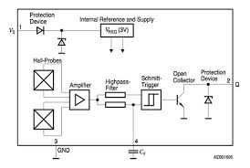
Components Used:
1. Braking kit of motorcycle: It consists of disc brake driven by motor and brake calipers of a motorcycle to reduce the cost of prototype.
2. 5/2 solenoid valve: Solenoid valve is used to bypass the braking circuit to actuate the brakes
3. Ultrasonic sensor: It is used to detect objects or obstacles upto a range of 10m
4. Reflector
5. PLC Circuit: Ladder logic relays to actuate the alarm and actuate the solenoid valve
3.2 Solenoid 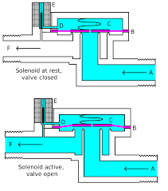Valve

The control valve is used to control the flow direction is called cut off valve or solenoid valve. This solenoid cut off valve is controlled by the emergency push button. The solenoid valve consists of electromagnetic coil, plunger and spring. The air enters to the pneumatic solenoid valve when the push button is in ON position. A plunger connects the closure device to the control element of the actuator. The spring acting on the control element forces the closure device down into the closed position on the valve seat. The pilot supply overcomes the spring force to lift the control element into the open position. These valves are mainly suitable for contaminated or extremely viscous process fluid. In this project we are supplying the signal to solenoid valve through ECU.

3.3 Pneumatic Cylinder
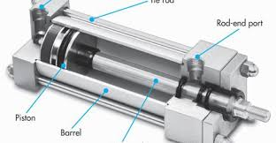
Both single acting as well as double acting cylinder can be used, accordingly solenoid valve vary. Generally 3/2 solenoid valve for the single acting cylinder and 5/2 solenoid valve for the double acting cylinder are use.
The compressed air from the compressor is passed through the regulator which is able to provide the required amount of pressure by adjusting it. There is pressure gauge arrangement on the compressor which is helpful for providing the required amount of pressure easily. This compressed and pressure regulated air is then passed through the solenoid valve. If solenoid valve is 3/2 then there will be only one outlet and if it is 5/2 then there will be two outlets for single inlet. This outlet from solenoid valve is/is directly connected to the pneumatic cylinder with the help of hose.

3.4 The Fundamental of Sensor
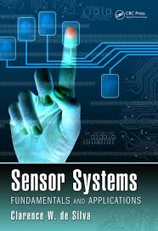
Sensor is an electrical device that maps an environmental attribute to a quantitative measurement. It is created to collect information about the world. Each sensor is based on a transduction principle which is conversion of energy from one form to another form.
3.4.1 The Fundamental of Ultrasonic Sensor
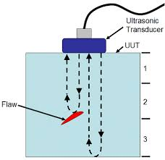
Ultrasonic ranging and detecting devices use highfrequency sound waves to detect the presence of an object and its range. The systems either measure the echo reflection of the sound from objects or detect the interruption of the sound beam as the objects pass between the transmitter and receiver. An ultrasonic sensor typically utilizes a transducer that produces an electrical output in response to received ultrasonic energy. The normal frequency range for human hearing is roughly 20 to 20,000 hertz. Transducers are devices that convert electrical energy to mechanical energy, or vice versa. The transducer converts received echoes into analog electrical signals that are output from the transducer. The piezoelectric effect refers to the voltage produced between surfaces of a solid dielectric (nonconducting substance) when a mechanical stress is applied to it. Conversely when a voltage is applied across certain surfaces of a solid that exhibits the piezoelectric effect, the solid undergoes a mechanical distortion. Such solids typically resonate within narrow frequency ranges. Piezoelectric materials are used in transducers, e.g., phonograph cartridges, microphones, and strain gauges that produce an electrical output from a mechanical input. They are also used in earphones and ultrasonic transmitters that produce a mechanical output from an electrical input. Ultrasonic transducers operate to radiate ultrasonic waves through a medium such as air. Transducers generally create ultrasonic vibrations through the use of piezoelectric materials such as certain forms of crystal or ceramic polymers.
3.4.2 Measurement Principle/Effective Use of Ultrasonic Sensor
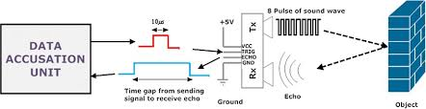
Ultrasonic sensor transmits ultrasonic waves from its sensor head and again receives the ultrasonic wavesand measured.
3.4.3 The advantages of Ultrasonic Sensor
ii. Less affected by target materials and surfaces, and not affected by color. Solid-state units have virtually unlimited, maintenance free life. Ultrasonic can detect small objects over long operating distances.
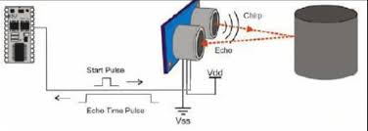

3.4.4 The Disadvantages of Ultrasonic Sensor
- Overheating of a wave emitter precludes the energy of ultrasonic waves emitted there from being enhanced to a practical level.
- ii. Interference between the projected waves and the reflected waves takes place, and development of standing waves provides adverse effects. iii. It is impossible to discern between reflected waves from the road surface and reflected waves from other places or objects.

4.MOBILE PARKING

- 100% wireless, hands-free, license plate frame based parking sensor with a mobile app for Android and iOS.
- Upgrade any car on your own with cutting edge automotive parking sensor technology with no wiring or having to hire a professional.
- Instant hands-free alerts to your mobile device, iOS and Android compatible; app
- launches automatically on Android, iOS receives click to launch notification.
1. Invert the sensor (turn upside down). Make sure you select the "Invert Sensor" option in the settings menu so the readings are inverted and read correctly after making the flip.
2. Use the small Allen key included in the key on the holes to the left and right of each sensor: Turn left to loosen. Adjust the sensors up with the app running to see how it affects the readings (don't stand in front of the sensors), then hold the sensor in position while turning the Allen key clockwise to lock the sensor into its new position.
Most false sensor readings are the sensor pointing downwards and hitting the ground, bumper, or hitch. Follow one of the two solutions above for an easy fix.

The number one reason for incorrect sensor readings is that the sensor is hitting an object unexpectedly. If you have a step, hitch, or otherwise protruding bumper, it may cause a false reading from the sensor.
Here are some solutions:
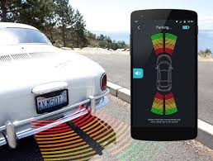

5. CASE STUDY ON AEBS

Participants were loaned the test vehicle shown in Figure 3 for a period of up to one week to allow familiarisation with the controls. The test car was an S80 loaned by Volvo that was retro-fitted with the City Safety system for purposes of the research. The system is only fitted to new cars, and was launched on the XC60 in November 2008. LIDAR sensor unit. The mileage travelled included an equal split between motorways as well as urban and rural roads, all of which were normal UK roads, for a combined distance of over 20,000 kms. Participants were aged between 25 and 55 years old, and all held full driving licences. During the road driving trials all the 11 drivers had the City Safety system operational, since it could not be deactivated on the test vehicle. For all drivers, no positive interventions of the City Safety system were reported, and no false interventions either. 50% of drivers reported that they felt safer than usual knowing that they were driving the car fitted with City Safety that
had the capability of preventing a low speed collision. 30% felt no different driving the vehicle compared to their usual driving. 10% of drivers felt more confident driving the car fitted with City Safety, and the remaining 10% felt more nervous.[2] 4.2 Result In order to identify an impending low speed impact the City Safety

system uses a LIDAR sensor mounted in the front windscreen. The car brakes are

automatically applied when an imminent collision is identified. The automatic braking can prevent impact under 15 km/h and can mitigate an impact between 15 and 30 km/h. The City Safety system prevents common low speed crashes where whiplash typically occurs.
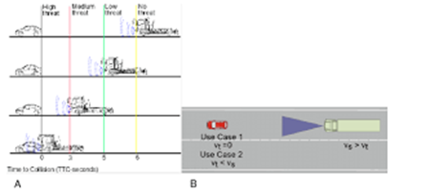
It shows potential for reducing the burden on the wider society as well as insurers. The UK estimates presented indicate the system could affect 351,000 crashes annually by preventing or mitigating the crash. The estimates show that City Safety could also save over 150,000 crashes involving whiplash injuries. This equates to an estimated cost saving of nearly €2 billion. Studies of driver responses in normal road driving showed no interventions of the system, including no false activations. Collision prevention testing involved drivers driving toward an inflatable target car resulting in automatic application of the brakes to prevent an impact. In these collision assessment tests the majority of drivers felt the instinctive urge to brake in response to the collision situation that was created. Drivers also stated that they understood that the system is designed for emergency situations only and they would not rely upon the system in normal driving. This driver study indicates that driver adaptation to the City Safety system seems unlikely. The City

Safety system appears to offer significant benefits to all drivers in preventing the most common sort of impacts. The system islow cost and can be readily made available across a new car fleet. Estimates presented in this paper indicate that significant reductions in injuries and repair costs are 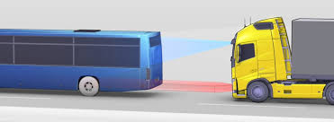
possible. Due to the late activation of the system in the collision process and the harsh and unpleasant emergency braking applied, an activation of City Safety is expected to discourage drivers from adapting to the technology. The braking system is a complex arrangement and simply changing one component may completely upset the whole set-up. Pedal ratio, plus bore sizes of the master cylinder, caliper pistons and wheel cylinders are all very critical to maintaining the correct system pressure, and safe braking performance. Weight distribution, tyre size and suspension can all have an effect. Therefore, I decided to do some research. Iknew I wasn't going to get the set-up bang on first time, but at least I wanted to get close. I had read a number of forum pages where builders of Low cost type cars complained of the rear locking up under heavy braking and didn't want the same.

6.SPEED LIMITOR

The configurable speed limiter limits driving speed to a value set by the driver within the speed range of 30 to 250 km/h (18.6 to 155.3 mph) – which is very helpful within city limits or construction zones, for example. When the preset limit is reached, the vehicle gently throttles the speed down. The speed limit is not exceeded even if the driver applies more pressure to the accelerator pedal. However, the driver can temporarily override the limit by kick-down, and the speed limiter can be completely deactivated at any time from the steering column stalk. The speed that has been preset is shown in the instrument cluster.
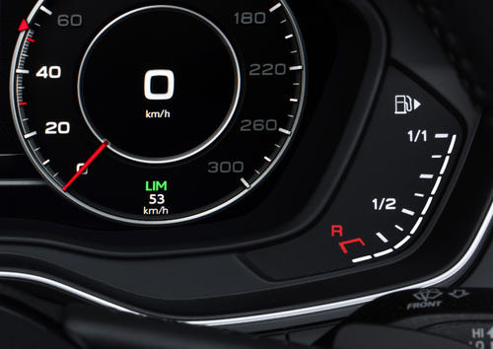

7.NIGHT VISION ASSIST

The night vision assist that Audi offers for multiple full-size models uses a far infrared camera. It reacts to the heat given off by objects. Converted to black and white images, the information can be viewed in the instrument cluster or Audi virtual cockpit. The cooler surroundings appear dark, while animals and people appear strikingly bright.
The system, which has a range of up to 300 meters (984.3 ft), can detect people and larger wild animals at distances between roughly 10 and 90 meters (32.8 and 295.3 ft) and highlights them with yellow markings. If a hazardous situation is detected, a warning sound is emitted. A warning symbol appears in the instrument cluster as well as in the head-up display. Depending on the headlights persons outside of town limits are illuminated with three short flashes of light.

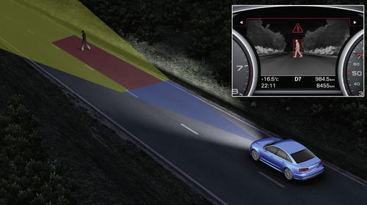

8.TRAFFIC JAM ASSIST

Traffic jam assist is a subsystem of adaptive cruise control (ACC) or adaptive cruise assist (ACA). In vehicles with an automatic transmission, traffic jam assist can assume certain steering tasks over a speed range up to 65 km/h (40.4 mph) on roads that are in good condition, as long as the traffic is moving slowly. The system uses the radar sensors and the front camera. It guides the car by making gentle steering movements within system limits and orients itself to lane markings, roadside structures and other vehicles on the road. When traffic jam assist reaches its system limits – such as when the traffic thins out or there is a sharp curve ahead – the driver must assume driving tasks again. If the driver does not, the system warns the driver in several stages. As a final measure, it autonomously brings the car to a safe stop.

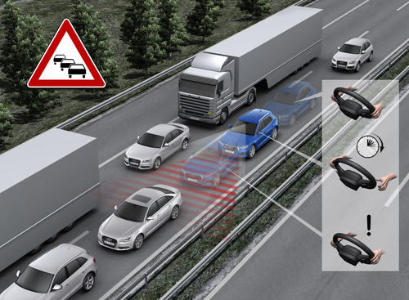

9.CENTRAL DRIVE ASSISTANCE CONTROLLER

Conditional automated driving at level 3 is based on two innovations: a sensor set with the laser scanner and a central driver assistance controller known as zFAS, for short. The roughly tablet-sized computer constantly processes sensor signals and uses them to create a complete image of the car’s surroundings. To do this, it uses processors from leading global companies – NVIDIA (Tegra K1), ALTERA (Cyclon V), Infineon (Aurix) and Mobileye with the EyeQ3 image processing engine.
The sensor data is read into the “fusion” layer in the zFAS unit and is merged to generate a sophisticated model of the surroundings. It includes moving objects, stationary obstacles and a road model. The latter is generated from the conventional navigation map and from road markings and borders that the sensors detect. The vehicle is guided precisely within its lane in the model, and this positional information flows into the navigation map that the driver sees. This information offers the driver many benefits, such as in complex intersection situations.
The zFAS serves as the central interface for piloted driving functions and for nearly all of the assistance systems. Whether the given system is the crossing assist, the emergency braking function, adaptive driving assistant or traffic jam pilot – its functions are no longer coupled to just a specific sensor. Each system makes use of the vehicle surroundings model and can operate more effectively as a result of this model’s high precision. This makes it possible for the vehicle, for example, to recognize the tail end of a traffic jam and brake appropriately.
The principle of a central fusion level based on standardized sensor interfaces gives Audi another advantage – independence from the specificity of sensors. Developers can replace individual sensors whenever better devices a 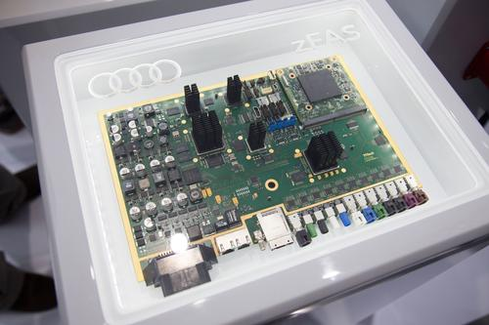

10.EXIT WARNING

Exit warning improves safety in city traffic. If the car has come to a stop and other vehicles or bicyclists classified as critical are approaching from the rear, the system warns passengers not to open the doors. The system does this using LED lights in the door panels. In a situation assessed to be hazardous, the LEDs flicker and light red. The LEDs of Audi side assist are also lit in the
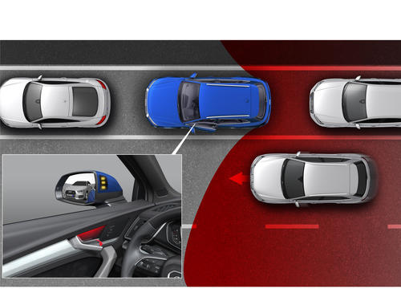

relevant exterior side mirror. The exit warning remains active for approximately three minutes after the ignition is turned off.
This system is based on the radar sensors of Audi side assist, which monitor the zones behind the vehicle and to the sides at the rear. Depending on the model the exit warning is extended by an additional feature: If the system is active, opening of the electronic door locks is delayed roughly one second.

11.CONCLUSION

- If we can reduced the Driving Interference of Braking and Give the Responsibility To Intelligence Sensor which will Take decision and initiate the Response To give Warning alarm First and if Distance of impact is Closing it will Apply brake Automatically and Stop the Vehicle in advanced. 2. Such that Distraction Driving is a Major Contributor to Accident death, thus by implementing this System we can reduced the Close impact Potential Accident. 3. By dragging the front seat at opposite direction to Impact and increase the Distance And Time Of Direct
Impact the death can be minimized and safety of vehicle also can improved, and

also it can add the new feature to the car which will attract the customer who prefer safety while traveling. 4. The results of the simulations showed that by using an energy absorbing seating system, crash deceleration can be effectively attenuated and occupant injuries significantly reduced in comparison to conventional seating systems. In future, physical crash tests will still be required as the final certification method for approval of a particular crashworthy mechanical system. However during the development process the application of computer simulation methods as presented in this paper show that it is possible to

12 REFERENCES
Coelingh, E., Jakobsson, L., Lind, H., & Lindman, M. (2007). Collision warning with auto brake – A real-life safety perspective (Paper No. 07-0450). 20th International Technical Conference on the Enhanced Safety of Vehicles (ESV). PDF available at https://www-nrd.nhtsa.dot.gov/pdf/ESV/Proceedings/20/07-0450-O.pdf
Avery, M., & Weeke, A. (2009). Autonomous braking systems and their potential effect on whiplash injury reduction (Paper No. 09-0328). Thatcham Research, United Kingdom. PDF and summary available via academic repositories (e.g., Semantic Scholar) at https://www.semanticscholar.org/paper/Autonomous-Braking-Systems-and-Their-Potential-on-Avery-Weekes/eea91493c98c917e4f2caaba7a1f59cdb4614387
Schram, R., Williams, A., & van Ratingen, M. (2013). Implementation of autonomous emergency braking (AEB): The next step in Euro NCAP’s safety assessment (Paper No. 13-0269). European New Car Assessment Programme (Euro NCAP). [Link not directly available online — cite at your institution if accessed in conference proceedings].
Doecke, S. D., Anderson, R. W. G., Mackenzie, J. R. R., & Ponte, G. (2012). The potential of autonomous emergency braking systems to mitigate passenger vehicle crashes. Australasian Road Safety Research, Policing and Education Conference, Wellington, New Zealand. [Link not freely available online; cite from conference proceedings or library database].
National Highway Traffic Safety Administration. (2012). Automatic emergency braking (AEB) report: An update of the June 2012 research report titled, “Forward-looking advanced braking technologies research report.” U.S. Department of Transportation. [Link not freely available online; cite government publication from NHTSA].
National Highway Traffic Safety Administration. (n.d.). Forward collision warning requirements report. U.S. Department of Transportation. [Link specific report within NHTSA online portal].
Georgi, A., Zimmermann, M., Lich, T., Blank, L., Kickler, N., & Marchthaler, R. (2014). New approach of accident benefit analysis for rear-end collision avoidance and mitigation systems (Paper No. 09-0281). Robert Bosch Corporation. [Access via conference proceedings or institutional repository].
AAA Foundation for Traffic Safety. (2001). The role of driver distraction in traffic crashes. http://www.aaafoundation.org/pdf/distraction.pdf
Hosking, S., Young, K., & Regan, M. (2007). The effects of text messaging on young novice driver performance. In I. J. Faulks, M. Regan, M. Stevenson, J. Brown, A. Porter, & J. D. Irwin (Eds.), Distracted driving (conference volume). [Available through academic conference proceedings].
Alonso, L., Milanés, V., Torre-Ferrero, C., Godoy, J., & de Pedro, T. (2011). Ultrasonic sensors in urban traffic driving aid-systems. Sensors, 11, 661–673. https://doi.org/10.3390/s110100661
Khade, R., Mahajan, H., Kedar, N., & Darwatkar, K. (2013). Automated braking system. International Journal for Engineering Applications and Technology, ISSN: 2321-8134. [Link dependent on journal archive; cite journal homepage or DOI if available].

